Reading Comprehension: Module 4 – What makes the world fascinating?

April 8-12, 2019
Texts  CORE TEXTS  - Picture Books (Informational)  - Africa, Rebecca Hirsch  - Antarctica, Rebecca Hirsch  - Asia, Rebecca Hirsch  - Australia, Rebecca Hirsch  - Europe, Rebecca Hirsch  - Introducing North America, Chris Oxlade  - South America, Rebecca Hirsch  - World Atlas, Nick Crane; Illustrations, David Dean  - Picture Books (Literary)  - Moon Rope, Lois Ehlert  - The Story of Ferdinand, Munro Leaf; Illustrations, Robert Lawson  - Why Mosquitoes Buzz in People’s Ears: A West African Tale, Verna Aardema; Illustrations, Leo and Diane Dillon  SUPPLEMENTARY TEXTS  - Article  - “5 Reasons Why Animal Moms Are Awesome,” April Capochino Myers  - Painting  - Carta Marina, Olaus Magnus  - Cornell Farm, Edward Hicks  - Washington Crossing the Delaware, Emanuel Leutze  - Photographs  - Earth from Space, Stöckli, Reto, et al.  - “Grand Canyon Scenic Splendor,” National Park Service  - “Patterns of Chinchero,” Descendants of the Incas  - Picture Books (Informational)  - When I Was Young in the Mountains, Cynthia Rylant; Illustrations, Diane Goode  - Poem  - “Lions Roar,” CanTeach  - Quotation  - “What is life?” Crowfoot  - Songs  - “Penguin Song,” Preschool Education  - "In the World is Carmen Sandiego? from Smithsonian Folkways," Smithsonian Folkways  - Videos  - “Antarctic Sights and Sounds,” James Napoli  - “Burkina Faso: Music,” Our Africa  - “Explore Views of the Burj Khalifa with Google Maps,” Google Maps  - “The Seven Continents Song,” Silly School Songs  - “Storm-Proofing the World’s Biggest Mud Building,” BBC Earth  - “Traditional Chinese Dance—‘Flowers Contend in Beauty’ by Li Qian, Lin Chen…”  - Websites  - “Americas—Fact Files,” Go Wild  - “Moles,” DK Find Out! | Wit & Wisdom Curriculum  Knowledge Goals  - Identify the seven continents.  - Describe the different natural features, things to do, and animals on each continent.  - Demonstrate understanding of maps and their purpose.  - Understand how illustrations, photographs, and words in a text communicate important information.  Reading Goals  - Ask and answer questions about unknown words in a text. (RL.K.4)  - Recognize and sort common types of text. (RL.K.5)  - Describe the relationship between the words and illustrations in a text. (RI.K.7, RL.K.7)  - Identify the reasons an author gives to support a point in the text. (RI.K.8)  - Identify similarities and differences between two texts on the same topic. (RI.K.9)  Writing Goals  - Use a combination of drawing, dictating, and writing to name a topic and state an opinion about the topic. (W.K.1)  - Respond to questions and suggestions from a peer and add detail based on feedback. (W.K.5)  - Collect evidence from the texts and use it to support responses to a prompt. (W.K.8)  Speaking and Listening Goals  - Confirm understanding of a text read aloud or information presented orally by giving an example of something heard or understood. (SL.K.2)  - Describe familiar people, places, things, and events to provide additional detail. (SL.K.4)  Language Goals  - Produce and expand complete sentences beginning each sentence with a capital letter. (L.K.1.f, L.K.2.a)  - Recognize and name end punctuation. (L.K.2.b)  - Identify new meanings of familiar words and use them accurately. (L.K.4.a)  - Use the most frequently occurring inflections and affixes to determine the meaning of an unknown word. (L.K.4.b)  - Demonstrate understanding of frequently occurring verbs and adjectives by relating them to their opposites. (L.K.5.b)  - Distinguish between shades of meaning of verbs describing the same general action by acting out their meanings. (L.K.5.d)  Major Assessments:  Focusing Question Tasks  3. Part 1: Write a sentence about what moment in the story the illustration on pages 17–18 (Why Mosquitoes Buzz in People’s Ears) depicts.  Part 2: Write an opinion paragraph about a favorite character in Why Mosquitoes Buzz in People’s Ears.  Part 3: In small groups, distinguish shades of meaning among the verbs tiptoe, walk, lumber, and scurry by acting them out. FQT 3  Part 2: Write an opinion paragraph about which continent, South America or Australia, has the most interesting animals. FQT 4  Part 2: Identify the different forms of end punctuation by circling examples from the text. FQT 5  New Read Assessments  1. After listening to a read-aloud of “5 Reasons Why Animal Moms Are Awesome,” identify two reasons the author gives to support the point, “African Elephant moms are awesome!” NR 1  2. After listening to a read-aloud of Moon Rope, use knowledge of word relationships and the illustrations to define key vocabulary. NR 2  3. Use the map on pages 38–39 of World Atlas to compare and contrast information that appears on the map of North America with information collected from Introducing North America. NR 3

FQ: How can a story transport you to a different place? | Monday (4.8) | Tuesday (4.9) | Wednesday (4.10) | Thursday (4.11) | Friday (4.12)
Reading Goal | I will answer questions about a text. | I will ask and answer questions about words I do not know in a text. | I will use illustrations and words in a text to help me understand a story better. |  | I will determine the essential meaning of a text.
Reading Lesson | SUBSTITUTE:  Read When Will it Be Spring and have students answer questions left by teacher | Lesson 18  The Lion’s Roar reading fluency. http://witeng.link/0410  Read fluency poem (first four lines)  “What does it mean to slide and glide? Are these movements smooth or choppy?”  “What does it mean to crawl? Is this a fast movement or a slow movement?”  Students will pantomime the movements of each character.  Teacher presents the cover of Why Mosquitoes Buzz in People’s Ears and asks if students think it’s a storybook or an informational text. Students explain their thinking.  Teacher explains that in some books there are words we do not know and that good readers take time to think about words they do not know, using pictures to help them.  Words to focus on: mischief, timid, fetch  Teacher uses the word mischief as a model (pp1-4) to show students how to figure out what a word means by using contextual and pictorial clues. Students will answer questions about how the pictures relate to the meaning of each word with a partner.  Once students understand the meaning of these tricky words, they will work in pairs to collect evidence for their next writing assignment. | Lesson 19  The Lion’s Roar reading fluency. http://witeng.link/0410  Read Fluency poem (6 lines)  “How is a monkey different from the snail? Do they move in the same ways?”  “Thinking about monkeys and snails and how they move, what kind of movements are leap and creep? Are they the same or different?”  “What do ants do? What does it mean to heap? Think of the way ants move and where they live to help you answer.”  Students will pantomime the movements of each character.  Teacher will explain that students will use the illustrations and words in a book to help them understand how each animal is moving in the story.  “Do the illustrations in a text move? How can we figure out how the animals are moving in this text?”  “What words did you hear to describe how the iguana moves?”  Teacher will read the next paragraph on page 4. Explain that the author does not use any action words to describe how the python moves. Ask:  “If the words do not tell us, how can we use the illustration? What do you notice about the python’s body that will help us understand how it moves?” slithering  Read the last paragraph on page 4.  “How do the words help us understand how the rabbit moves?”  Teacher will point to the rabbit in the illustration that is scurrying out of the burrow.  Read the first paragraph on page 5.  “How do the words help us understand what the crow does?”  Read the second paragraph on pages 5–6. If needed, define leaping as “jumping a long distance.”  “How do the words help us understand what the monkey does?”  Students will respond to each question by telling a partner what they see/hear in the book that helps them understand how each animal moves. Students can move to show what they see and hear if that is easier than speaking. | Mini-Production @ 10am  Math lesson will be held in afternoon instead of ELA | Lesson 20  The Lion’s Roar reading fluency. http://witeng.link/0410  Read fluency poem (all lines)  “How are people different from animals? How does this poem give us one example of a difference?”  Students will pantomime the movements of each character.  Teacher will explain that folktales often tell a story about the world or teach a lesson. Students will discuss what they think the lesson of the story is.  Read the text aloud. After the reading, ask the following TDQs.  1. How did King Lion use questions to learn why the night was lasting so long?  2. What might have happened if King Lion only listened to Mother Owl and didn’t continue to ask more questions?  3. At the end of the story, it says the mosquito had a “guilty conscience.” What is a guilty conscience? Why might the mosquito feel guilty?  4. What lines do you hear repeated over and over in the text? Why do you think the author repeated those lines?  Students will discuss each answer to the question with a small group, taking turns talking.  As students answer the questions, teacher will write answers down on an anchor chart or white board for students to refer to after the questions have all been answered.  Students will discuss what they think all of these things are telling them and what it is trying to teach them.
Writing Goal |  | I will collect evidence from a text to help me with my writing. | I will collect evidence from a text to help me with my writing. |  | I will write to tell about my favorite character from a text and tell why I liked that character.
Writing Lesson |  | Students will fill in their evidence organizer to describe each animal’s appearance in the story.  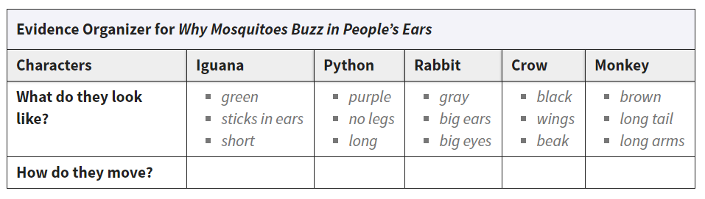 | Students work to write in how each animal was moving in the story as the lesson goes along.  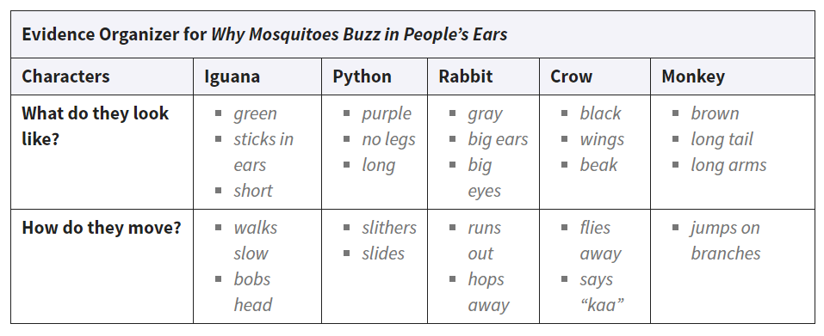 |  | - “What parts of Why Mosquitoes Buzz in People’s Ears help transport you to the West African forest? How does the story take you there in your imagination?”  Use responses to explain that they will be writing about one of the elements from the text that can help transport them into the story: the characters.  ASSESSMENT:  Tell students that they will respond to the following prompt for their Focusing Question Task.  Who is your favorite character in Why Mosquitoes Buzz in People’s Ears? Why?  Display the Evidence Organizer for Why Mosquitoes Buzz in People’s Ears. Explain that students will write an opinion paragraph. They will think about the different evidence they have collected and form an opinion about which character is their favorite.
Phonics Goal | I will blend sounds to read words. I will answer questions about a text. | I will blend sounds to read words. I will answer questions about a text. | I will blend sounds to read words. I will answer questions about a text. | I will blend sounds to read words. I will answer questions about a text. | I will blend sounds to read words. I will answer questions about a text.
Skills Strand:  Phonics Lesson | Unit 9 Lesson 14  Review all sounds learned  Foundational Skills  • Warm-Up:  - Tricky Word Review  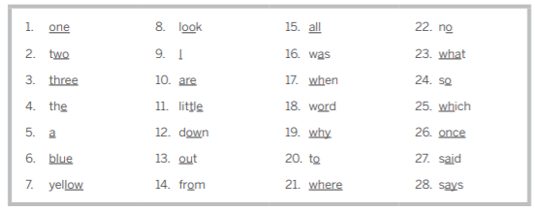  - Sound/Spelling Review  • Practice Uppercase and Lowercase Letters (table work for centers)  Reading  • Reread “A Gift from Mom”  • Review “A Gift from Mom” 14.2 answer questions from story | Unit 9 Lesson 15  Review all sounds learned  Foundational Skills  • Warm-Up:  - Oral Blending  - Sound/Spelling Review  • Wiggle Cards  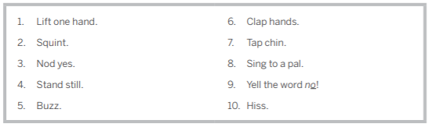  • Mark the Sentence (table work for centers) | Unit 9 Lesson 16  Review all sounds learned  Foundational Skills  • Warm-Up: Tricky Word Review  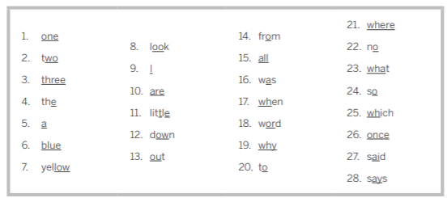  • Introduce Tricky Word: Were  Students use the word in a sentence with a partner  Student build “were” with playdough in centers  Reading  • Introduce the Story  Vocabulary: munch  • Read “Bug and Frog”  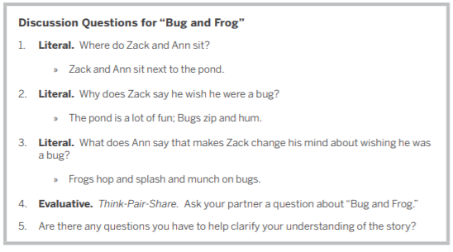  • Review “Bug and Frog” 16.1 workbook page, answering questions with a partner | Unit 9 Lesson 17  Review all sounds learned  Foundational Skills  • Introduce Tricky Words: Here, There  Students use the word in a sentence with a partner  Student build “here” and “there” with playdough in centers  there  https://www.youtube.com/watch?v=g4-22fRXfXw  • Practice Tricky Words 17.1  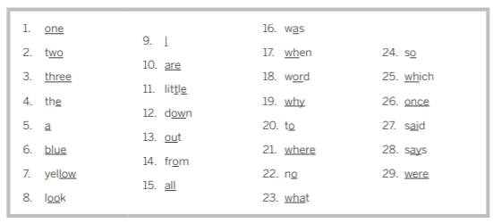  Reading  • Introduce the Story  Vocabulary: slick  • Read “Swing that Net”  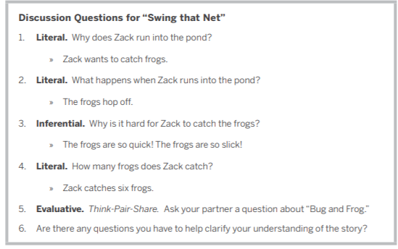  • Review “Swing that Net” 17.2 workbook page with a partner to answer questions | Unit 9 Lesson 18  Review all sounds learned  Foundational Skills  • Warm-Up: Tricky Word Review  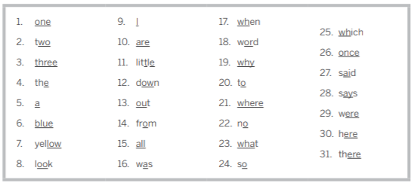  • Dictation with Phrases 18.1  • Complete the Sentences 18.2  Reading  • Introduce the Story  Vocabulary: grips  • Read “Spot’s Bath”  