Landforms

March 18-22, 2019
Social Studies: Geography
Distinguish between areas of Earth covered by land and water

Focus Skills:
- Tell where water and land are found.
- Tell differences between landforms
- Name specific landforms

 | Monday (3.18) | Tuesday (3.19) | Wednesday (3.20) | Thursday (3.21) | Friday (3.22)
Learning Target | I will define the word “landform” and discuss properties of a landform. | I will define the word “mountain” and discuss properties of a mountain. | EARLY DISMISSAL | I will define the word “volcano” and discuss properties of a volcano. | I will compare and contrast information on two landforms to tell how they are the same and different.
Social Studies  Geography  Landforms | Landforms  https://www.getepic.com/app/read/13750  Teacher will read story and discuss important vocabulary from story.  S will ask and answer questions from the book.  Students and teacher work together to create an anchor chart, including all landforms discussed in the text.  Students will work in groups of three with index cards, drawing/labeling the landforms they heard about in the text. Each student must draw a different landform.  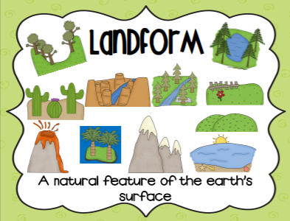 | Mountains  https://www.getepic.com/app/read/52051  Teacher will read ONLY Chapter 1 in story and discuss important vocabulary from text.  S will ask and answer questions from the book.  Students and teacher work together to create an anchor chart, including information they learned about a mountain.  Students will fill in a word web to tell what they learned about mountains.  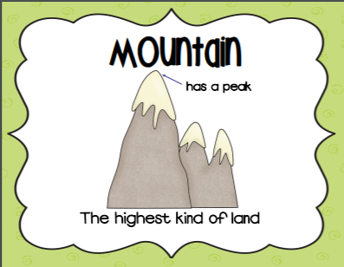  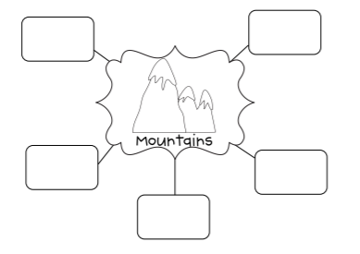 |  | Volcanoes  https://www.getepic.com/app/read/51264  Teacher will read story and discuss important vocabulary from story.  S will ask and answer questions from the book.  Students and teacher work together to create an anchor chart, including information they learned about a volcano.  Students will fill in a word web to tell what they learned about volcanoes.  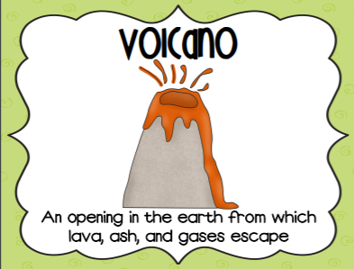  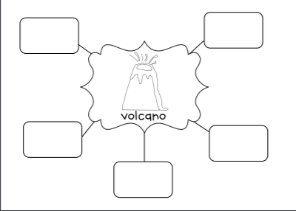 | Students will review the information they collected about mountains and volcanoes. With a partner, they will work to create a mountain and volcano with clay or playdough, using information to help them create them accurately.  Students will participate in an experiment to “erupt” a volcano. Students will make predictions about different combinations of ingredients to tell what they think will happen.  Combinations: water/baking soda  Vinegar/flour  Baking soda/vinegar  Teacher uses each of the ingredients with a funnel on a plate and students write down observations for each set of ingredients.  Students will work as a class to fill in a Venn Diagram, comparing and contrasting the two landforms:  